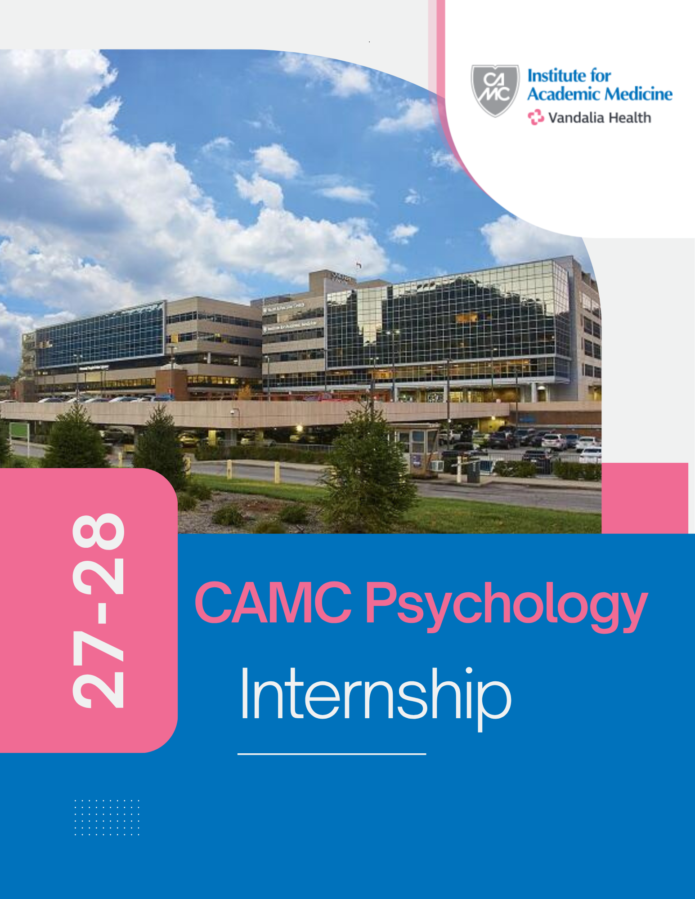


Doctoral Psychology Internship Program
Application Due Date: November 13, 2026 (11:59 p.m.)

CAMC Doctoral Internship Training Program
This APA-Accredited predoctoral internship in Clinical Psychology is sponsored by Charleston Area Medical Center (CAMC) in concert with the CAMC Institute of Academic Medicine. It is housed within an academic medical center and considered a CAMC Graduate Medical Education (GME) program. CAMC is a teaching hospital hosting several other training programs with medical students and residents. As a result, there are opportunities to engage in collaborative learning opportunities with other disciplines.

For more in-depth information: CAMC Psychology Internship
For information regarding Resident Compensation and Benefits: CAMC GME

We offer three tracks:
- Health Service Psychology track (3 positions; APPIC match #163711)
- Child Clinical Psychology track (2 positions APPIC match #163712)
- Adult Neuropsychology Track (1 position; APPIC Match #163713).

Accreditation Status
The Doctoral Internship at Charleston Area Medical Center (CAMC) is accredited by the American Psychological Association (APA). For information regarding this program’s accreditation status, please call or write:

Office of Program Consultation & Accreditation
American Psychological Association
First Street NE, Washington DC 20002-4242
Phone: (202-336-5979)/ Email: apaaccred@apa.org
Web: www.apa.org/ed/accreditation

Training Model and Philosophy
The CAMC Psychology internship program provides interns with in-depth broad and general training in Clinical and Health Psychology within an Academic health center. Our program follows a professional/scholar model, and we firmly adhere to the integration of science and practice for internship training.

The overarching goal of the internship is to prepare our doctoral interns for the independent practice of psychology in a variety of settings. With this goal in mind, we utilize a comprehensive approach to training to include clinical training, scholarly work/research, and didactic experiences. Training is sequential, cumulative, and graded in complexity in each rotation over the year. Our faculty are dedicated to training and provide in-depth supervision. We follow a developmental approach to supervision as we encourage interns to function more independently as they progress in their training. Additionally, we stress multidisciplinary and interdisciplinary functioning, behavioral theoretical approaches, and diversity sensitivity/humility. Also stressed are personal and professional development throughout the training year. Lastly, our training model is a combination of support and flexibility as the experiences offered in our program emphasize comprehensive training while also providing flexibility in that trainees can select different areas of focus.

Agency Overview
CAMC is the largest hospital complex in West Virginia. Located in the state capital, CAMC is a nonprofit regional referral and academic medical center with more than 8,000 employees. The medical center is made up of four hospitals: CAMC General Hospital, CAMC Memorial Hospital, CAMC Teays Valley Hospital and CAMC Women and Children's Hospital. It offers a number of specialized inpatient, outpatient, prevention and emergency services, and extensive state-of-the-art facilities and centers of excellence for the provision of clinical care.

Eligibility for Application to Internship Program:
- We accept applications from graduate students in good standing from APA accredited doctoral programs in clinical and counseling psychology.
- Applicants must have a master’s degree in psychology or equivalent education.
- Applicants must be legally authorized to work in the United States at the time of their application and throughout the internship year.

CAMC is an Equal Opportunity Employer. We consider all applications for internship without regard to race, color, ethnicity, sex, age, national origin, religion, sexual orientation, gender identity and/or expression, genetic information, medical condition, marital status, veteran status or disability.

Application Procedures
As a member in good standing of APPIC, this internship program maintains compliance with APPIC’s guidelines on recruitment and selection. We participate in the National Match and follow the APPIC match policies, agreeing that no person at this training program will offer, solicit, accept, or use any ranking-related information from any intern applicant or graduate program.

All application and associated materials must be received by 11:59 p.m. on November 13, 2026.

Interviews
Candidates will be invited for virtual interviews (via Zoom), which will be held on the following dates:
- Health Service Psychology Track: | Jan. 08, 15, and 22
- Child Clinical Psychology Track: | Jan. 07, 14, and 21
- Adult Neuropsychology Track: | Jan. 13 and 20

Track Offerings
- Health Service Psychology Track (HSP): developed to provide exceptional psychology training in the academic medical center setting. The core rotations provide a solid foundation for the application of assessment and intervention skills with adults across ambulatory, inpatient, and consultation settings. Optional rotations are available to extend those skills into integrated primary care and specialty clinic settings, as well as provide opportunities for more focal training in specific intervention modalities. Interns on the HSP track have additional specialty assessment opportunities and may wish to dedicate focused time to research and scholarship.

- Child Clinical Psychology Track (CT): This specialty track offers an array of training opportunities for interns who are interested in the assessment and treatment of children and adolescents. Opportunities include outpatient therapy, assessment, and psychological consultation in specialty medical clinics. Interns will have the opportunity to provide evidence-based treatments to include Parent Child Interaction Therapy, Trauma Focused Cognitive Behavioral Therapy, and Dialectical Behavioral Therapy for Adolescents.

- Adult Neuropsychology Track (NPT): Developed in accordance with the Houston Conference Guidelines and the Minnesota Conference Guidelines. Interns will conduct neuropsychological evaluations with a variety of neurological and cognitive presentations. Interns will participate in weekly neuropsychology-focused case conferences. Applicants for this track are expected to have relevant coursework and practica experiences in clinical neuropsychology prior to starting internship.
Program Structure for Health Service Psychology Track
The year-long internship includes both required and optional rotations with the schedule developed to meet the intern’s individual training needs. The required and optional rotations are mixed over the year, so all required experiences do not have to be completed before optional training begins.

Required Rotations include:
- Outpatient Psychological Treatment
- Assessment Services
- Adult Psychiatry Inpatient
- Consultation/Liaison

Optional Rotations include:
- Cardiac Rehabilitation
- Cognitive Behavioral Therapy Training
- Dialectical Behavioral Therapy Training
- Integrated Primary Care
- Psychological Assessment (optional extended rotation)
- Research
- Women’s Health

Required Rotation Training Experiences for Health Service Psychology Tracks:
- Psychological Treatment Outpatient: This required rotation is designed to hone skills in delivering evidence-based, best-practice interventions in the ambulatory behavioral medicine setting (Department of Behavioral Medicine and Psychiatry). Health Service Psychology track interns provide individual psychological therapy to adult patients referred by psychiatry and internal medicine/psychiatry colleagues in the department, as well as community partners. Interventions commonly provided include CBT and Third Wave CBT approaches. HSP interns may wish to pursue additional training focused on dialectical behavior therapy, ACT, and evidence-based trauma-focused interventions in this rotation. This rotation runs throughout the year, with HSP interns offering two-three clinic days per week.

- Psychological Assessment: This experience is designed to enhance psychological assessment skills, as well as increase knowledge of psychometric properties. Interns will complete at least 10 integrated reports within a two-block schedule timeframe, or their rotation length of time may be extended.

- Adult Psychiatry Inpatient: The internship experience on the inpatient psychiatry service is designed to provide broad, active participation in the multidisciplinary treatment of adult psychiatry inpatients. Working closely with the team, psychology interns participate in diagnosis, treatment planning, rounds and discharge planning daily and provide direct services to selected patients in the form of brief psychological psychotherapy. They participate as co-leaders of the daily 1:15 p.m. group therapy session under the supervision of psychology faculty. This rotation is typically one month in duration.

- Consultation Liaison:
  - Behavioral Medicine C/L Service: Interns will work with a team of residents and psychiatry attendings to provide consultation services for patients with psychological concerns admitted for medical conditions.
  - Family Medicine C/L Service: Interns will work with an inter-professional team to provide consultation services on the family medicine inpatient service.

Optional Rotations:
- Cardiac Rehabilitation: On this rotation, interns will have the opportunity to participate in individual and/or couples therapy with cardiac patients, depending on patient need. Interns can participate in intake screening and diagnostic assessment pertinent to a cardiac population. They can co-lead or lead psychoeducational classes for rehabilitation participants and families. Interns can observe cardiac surgery if desired.

- Cognitive Behavioral Therapy Training: This rotation provides interns with the opportunity to enhance their CBT skills. Traditional CBT and “third wave” approaches are incorporated. More in-depth study and implementation of cognitive-behavior therapy also occurs through participation in the weekly CBT supervision group, in which members each have at least one case they follow.
- Dialectical Behavior Therapy Services program: The CAMC DBT Services Program rotation provides broad and in-depth specialty training in all components of Dialectical Behavior Therapy (DBT) under the supervision of DBT program faculty.
  - The Comprehensive DBT Rotation: This option is a 12-month/year-long rotation designed to develop full competency in all modes of treatment in DBT. Interns on the Comprehensive DBT rotation maintain a training caseload of at least two DBT patients (which may be adults, adolescents or both). As part of training, interns (1) conduct pre-treatment consultations to determine the appropriateness of DBT for referred patients; (2) provide individual DBT/DBT-A to patients; (3) provide telephone skills coaching to their individual patients (Note: DBT telephone skills coaching is provided based on the intern’s own individual limits; we stringy encourage interns observing limits to manage their well-being and DO NOT require interns to be available 24/7 for skills coaching); co-lead DBT Skills Training Classes/Groups, including leading didactic segments of skills training classes, helping to manage behavior during skills classes, and reviewing patients’ homework; (4) participate in and periodically lead weekly DBT consultation team meetings.
  - The DBT Skills Training Rotation: This option is for interns who are interested in a basic introduction to DBT by learning more about some components of DBT. This rotation is for interns who are NOT interested in learning the full DBT model. This rotation consists of a commitment of either eight or 16 weeks, during which interns co-lead at least two adult and/or adolescent skills training class modules and attend weekly consultation team meetings. The emphasis is on exposure to the skills taught in DBT, and to the inner workings of a DBT consultation team.

- Integrated Primary Care: The Integrated Primary Care rotation offers a variety of training opportunities at the CAMC Family Medicine Center of Charleston and the Cabin Creek Health Systems primary care clinics. The clinical options of this rotation provide valuable opportunities to address the needs of a population of patients who have been characteristically underserved. Such patients often have difficulty accessing mental health facilities for care and are more likely to find comfort in behavioral health interventions offered in an integrated primary care setting. Interns are expected to precept during Family Medicine resident clinic hours and during the clinic day at CCHS. Precepting affords the intern a unique opportunity to collaborate in patient care and to teach medical professionals what they know about human behavior. While precepting, interns will also learn more about the referral process for patients with behavioral health issues and will provide a valuable resource for patients at the Family Medicine and CCHS health centers. Interns are welcome to tailor their rotation experience to include a preferred combination of the available settings:
  - CAMC Department of Family Medicine (resident outpatient clinic):
  - Cabin Creek Health Systems (FQHC)
    - CCHS Integrated Behavioral Health (community health center)
    - CCHS Comprehensive Addiction and Recovery Program (integrated addiction medicine)

Research Rotation: The Research Rotation provides interns with an opportunity to participate in a variety of ongoing clinically oriented research projects in the WVU Department of Behavioral Medicine and Psychiatry or departments with which we partner in WVU and CAMC. Interns may participate at any level of the research process ranging from data collection in experimental studies and serving as assessors or project therapists in clinical trials, to management of research databases and presentation of research results. Interns are expected to prioritize the completion of their dissertation research and typically do not participate in a research rotation before their work with their dissertation is complete.

Women's Health: The Women’s Health rotation offers additional experience in integrated care in outpatient clinic settings, where interns work collaboratively with OB-GYN health providers such as physicians, nurses, midwives and peer recovery coaches to meet brief intervention and consultation needs for patients. Rotation locations include OB-GYN clinics at CAMC Women and Children’s Hospital and St. Mary’s Women & Family Care Center. Common concerns include peripartum concerns, infertility and pregnancy loss, trauma and abuse, substance use, sexual health concerns, physical health concerns, interpersonal relationship distress and adjustment to new motherhood. The Women’s Health rotation takes place at CAMC Women and Children’s Hospital, approximately 4.5 miles away (approximately 10-minute drive) from CAMC Memorial Hospital.

Program Structure for Child Clinical Psychology Track
The required rotations for the CT parallel rotations required in the health service psychology track, except that the CT does not require an inpatient rotation. Due to the rotation schedule, CT does not offer optional rotations, except for research.
- Outpatient Psychotherapy Rotation: Interns on the CT primarily provide specialized, evidence-based treatments in the CAMC Behavioral Medicine Department. These include Parent Child Interaction Therapy, Trauma Focused Cognitive Behavioral Therapy, Dialectical Behavioral Therapy.

- Child and Adolescent Psychological Assessment: Interns on the CT complete at least 10 child or adolescent integrated reports during the training year. Dr. Brown most often received referrals for younger children ages 3 to 5 for assessment of autism spectrum and ages 6 to 14 for learning, cognitive and executive function concerns. Dr. Brown also administers the ADOS, among other specialty tools (e.g., WISC, WIAT, WPSSI, DKEFS, Children's Memory Scale, BASC, Child Development Inventory, Adaptive Assessment System). Interns may have opportunities to work with Drs. Keener and Weisenmuller providing psychological diagnostic clarification evaluations for 18-23-year-olds. Finally, CT interns may wish to participate in forensic assessment of children with Dr. Weisenmuller. Neuropsychological assessment experience is NOT available for the Child Clinical Psychology specialty track.

- Psychological Consultation Rotation: Interns on the CT participate in Pediatric specialty clinics alongside medical specialist colleagues, supervised by psychologists Dr. Brown and Dr. Hughes. CT interns work with their supervisors for four and a half day clinics each month for the duration of the intern year, with some flexibility in which clinics and the frequency of consultation. CT interns meet regularly with the faculty psychology supervisor to discuss cases in clinic, consultation methods and treatment plans.

Program Structure for Adult NeuropsychologyTrack
The Adult Clinical Neuropsychology track at CAMC provides extensive training in clinical neuropsychology. A major area of focus is adult neuropsychological assessment. The required rotations for the NPT parallel rotation are required in the health service psychology track, with some reduction in outpatient psychotherapy to half a day, along with the addition of half a day of a cognitive rehabilitation skills group rotation.

Interns matching into the Neuropsychology track will complete a one-year neuropsychological rotation. The rotation is full-time except for designated blocks to accommodate required rotations. When interns are on the one-month inpatient rotation (see HSP required rotations), they will participate in Dr. Chantel Weisenmuller's ADHD evaluations clinic rotation throughout that training block. Following completion of the required inpatient and C/L rotations, NPT interns may elect to participate in an optional rotation for one block/month or resume full-time neuropsychological assessment.

Neuropsychology Rotations:
- Neuropsychological Assessment: Interns will have supervised clinical experiences in outpatient neuropsychological assessments. Assessment experiences include assessment of neurodegenerative disorders, traumatic brain injuries, and medical and psychiatric disorders affecting cognitive functioning.

- ADHD Clinic: The purpose of this clinic is to provide evidence-based assessment of adults with whom have been referred for an ADHD evaluation. Interns are expected to assess for ADHD, as well as any other conditions/causes that may be exacerbating or contributing to their presentation. As noted above, this is a one-month long rotation.
- Cognitive Rehabilitation Skills Group: Interns will co-lead with neuropsychology post-doctoral fellows a cognitive skills group. Options include CogSMART and/or ME-CCT-MCI. These are skills groups to help patients develop strategies in areas of attention, problem-solving, executive functioning, and memory. Both groups were originally developed at University of San Diego and San Diego VA.

Program Wide Additional Required Experiences
The following experiences are additional learning opportunities regardless of track.

Additional Required Experiences:
Weekly
- Psychology seminars and interdisciplinary Grand Rounds
Monthly
- One-hour Balint group led by Dr. Scott Fields
- Journal Club led by Dr. Patrick Kerr
Depending on the rotation, the interns may participate in team meetings, such as through the Disordered Eating Center Team and DBT Consultation Team. Certain rotations (e.g., neuropsychological assessment, eating disorders and child psychology) have additional seminar/consultation options that interns may attend as appropriate. Interns are actively involved in research projects with faculty and other trainees.

Required Presentations:
- Each intern is required to create and present an evidence-based health care disparities lecture in Grand Rounds.
- Depending on the rotation, interns may be asked to present a topic during interdisciplinary Grand Rounds.

Community and Culture
Recreational activities are plentiful with white water rafting, snow skiing, mountain biking, fishing, hunting, and camping for outdoor enthusiasts, not to mention several golf courses, tennis facilities, professional baseball and an ice-skating facility. Cultural opportunities in Charleston include the WV State Symphony, Mountain Stage, local theatre and national touring performances. Many of these are housed in The Clay Center for the Arts and Sciences, across the street from CAMC General Hospital.

CAMC's program and the city of Charleston offer a perfect balance of academic excellence and recreational activities. Visit with us and explore the exciting possibilities waiting for you in wild and wonderful West Virginia.

